CSS Animations & Transitions

Definition
# Source: AI Source: Provided by: [Data Path: Persons Table -> ID Column: 1, Name_En Column: Motasem Essam] -> From: [Chatgpt (GPT‑5 Mini)] on [2/12/2026]
CSS Animations & Transitions are web design techniques used to create movement and visual effects on web elements to improve user experience and make a website more interactive and engaging.

Simple Definition
# Source: AI Source: Provided by: [Data Path: Persons Table -> ID Column: 1, Name_En Column: Motasem Essam] -> From: [Chatgpt (GPT‑5 Mini)] on [2/12/2026]
CSS Animations & Transitions = adding movement and effects to elements on a webpage.

How CSS Animations & Transitions Work
# Source: AI Source: Provided by: [Data Path: Persons Table -> ID Column: 1, Name_En Column: Motasem Essam] -> From: [Chatgpt (GPT‑5 Mini)] on [2/12/2026]
• Transitions: change an element smoothly from one state to another (e.g., hover effect)
• Animations: allow more complex and continuous movements using keyframes
• Use CSS properties like transition, animation, and @keyframes
• Control properties such as duration, timing, delay, and iteration

Purpose of CSS Animations & Transitions
# Source: AI Source: Provided by: [Data Path: Persons Table -> ID Column: 1, Name_En Column: Motasem Essam] -> From: [Chatgpt (GPT‑5 Mini)] on [2/12/2026]
• Improve user interaction
• Make websites more visually appealing
• Guide user attention to important elements
• Provide feedback (e.g., button hover effects)
• Enhance user experience

Advantages
# Source: AI Source: Provided by: [Data Path: Persons Table -> ID Column: 1, Name_En Column: Motasem Essam] -> From: [Chatgpt (GPT‑5 Mini)] on [2/12/2026]
• Smooth and attractive visual effects
• Improves user engagement
• Enhances usability (clear feedback)
• No need for JavaScript in many cases
• Lightweight and fast

Disadvantages
# Source: AI Source: Provided by: [Data Path: Persons Table -> ID Column: 1, Name_En Column: Motasem Essam] -> From: [Chatgpt (GPT‑5 Mini)] on [2/12/2026]
• Overuse can make the website distracting or annoying
• Can affect performance if not optimized properly
• May cause accessibility issues for some users
• Requires understanding of CSS to use effectively
• Some animations may not work well on older browsers
• Complex animations can be difficult to manage

Examples
# Source: AI Source: Provided by: [Data Path: Persons Table -> ID Column: 1, Name_En Column: Motasem Essam] -> From: [Chatgpt (GPT‑5 Mini)] on [2/12/2026]
• Button changing color when hovered
• Smooth fading in/out of elements
• Sliding menus or dropdowns
• Loading spinners or progress animations
• Animations when scrolling down a page

Difference Between CSS Animations & Transitions and Other Techniques
# Source: AI Source: Provided by: [Data Path: Persons Table -> ID Column: 1, Name_En Column: Motasem Essam] -> From: [Chatgpt (GPT‑5 Mini)] on [2/12/2026]
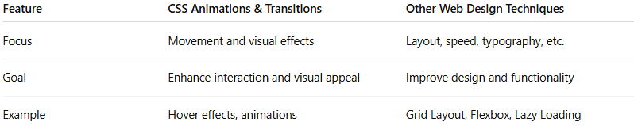
Feature | CSS Animations & Transitions | Other Web Design Techniques
Focus | Movement and visual effects | Layout, speed, typography, etc.
Goal | Enhance interaction and visual appeal | Improve design and functionality
Example | Hover effects, animations | Grid Layout, Flexbox, Lazy Loading

